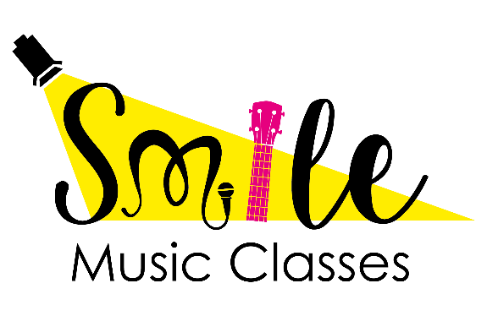
Registration Form 2019-2020
Pop/Rock Choir
Beginner Ukulele
Intermediate Ukulele
Beginner Guitar
Intermediate Guitar
___________________________________________________________________________
Child’s name: _____________________________________________ Date of birth: _____________________
School: _____________________________________________________________ Class: ____________________
Home Address: _________________________________________________________________________________
Parent/Guardian’s name(s): _________________________________ _______________________________
Contact number(s): _________________________________ ________________________________
Does your child have any medical conditions we should be aware of? _____________
If yes, please specify: ___________________________________________________________________________
Do you give consent for your child to appear in photographs and videos to advertise
SMILE Theatre & Music Classes? Please circle one: Yes No

Please note that fees are charged per term. See Payment Sheet for more information.

To help us comply with the rules of the General Data Protection Regulation (GDPR), please indicate that you give your consent for SMILE Theatre & Music Classes to use the personal data you have shared on this form to contact you regarding changes to class times/venues, cancellations and to advertise any future events.

Yes, I give my consent. No, I do not give my consent.

E-mail address: ________________________________________________________ Date: __________________

